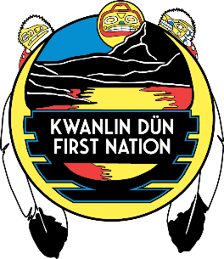
Statement of Duties – Labourer – Fire Smart
Labourer

Kwanlin Dün First Nation Government is pleased to inform you that you are the successful candidate for the above noted position.

Reporting to the Crew Supervisor, the Fire-Smart Labourer is a contributing member of the Fire Smart crew ensuring the safety of himself and other crew members through the employment of safe practices and following directions. The Labourer must be available during the work day, as indicated by the Crew Supervisor and commit to the Fire-Smart program.

The main duties and responsibilities of the 2019 Fire-Smart Labourer include:
- Wear safety equipment at all times and dress according the weather conditions
- Work within the safety procedures and follow directions
- Working as a team member with minimal supervision
- Removal, pile and burn the brush that has been cut by the Chainsaw operator
- Perform other duties as required
- Perform other duties as required

Qualifications and Requirements:
- Experience working outdoors in a variety of weather conditions
- Standard First Aid & CPR are required - provide certification
- Demonstrate physical wellness and healthy lifestyle (alcohol and drug free)
- Experience working safely with a team demonstrating a positive attitude
- Class 5 Yukon Driver’s License and acceptable driver abstract is an asset (include a copy with your resume)
- Physically fit, able to lift up to 50 lbs. independently
- Required to abide by safety legislation and KDFN safety policies & procedures
- ISETS eligibility is an asset
*Please note: Workers will only be paid for the hours worked and approved. Should work be completed prior to the completion of the term, every effort will be placed into finding further work until the designated funds of the program expire. Should the funds be depleted prior to the completion of the term, the program will end at this time.
All employees are expected to follow all KDFN law, policies, procedures and guidelines in a harmonious and cooperative manner, creating a team approach in their duties for KDFN’s future success. Mandatory confidentiality is a condition of employment for all staff of Kwanlin Dun First Nation, and failure to comply may result in dismissal.
I understand the terms and conditions of the duties as identified above and understand this may not be a full description of the duties I will perform.
Employee: Date:
Supervisor: Date:
Human Resources: Date:

